1. Rename the virtual machine of “corrupted” vxrail manager
2. Create a new virtual machine with ova file:
3. Search key word “VxRail <version> release VxRail Manager Package for Restore” from <https://support.emc.com/search>:

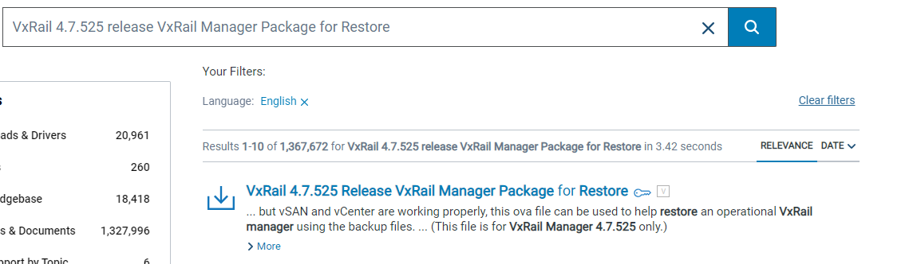

1. Deploy the virtual machine with ova file downloaded in last step:

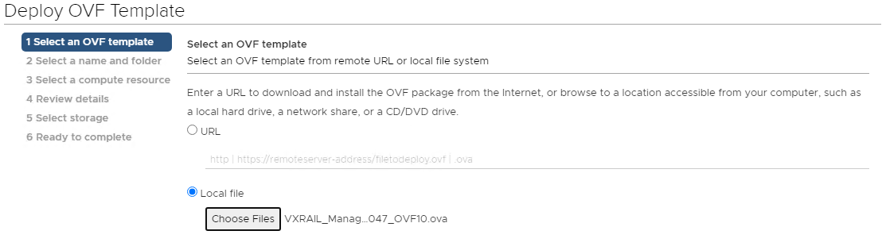

1. Name this new virtual machine as “VxRail Manager” and choose an apt folder:

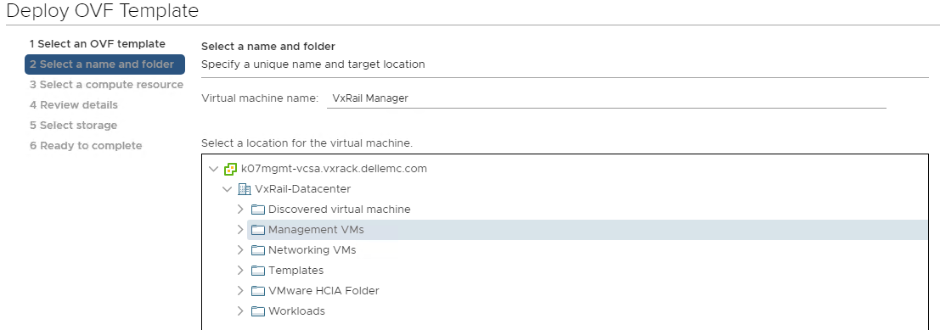

1. Choose the apt resource:

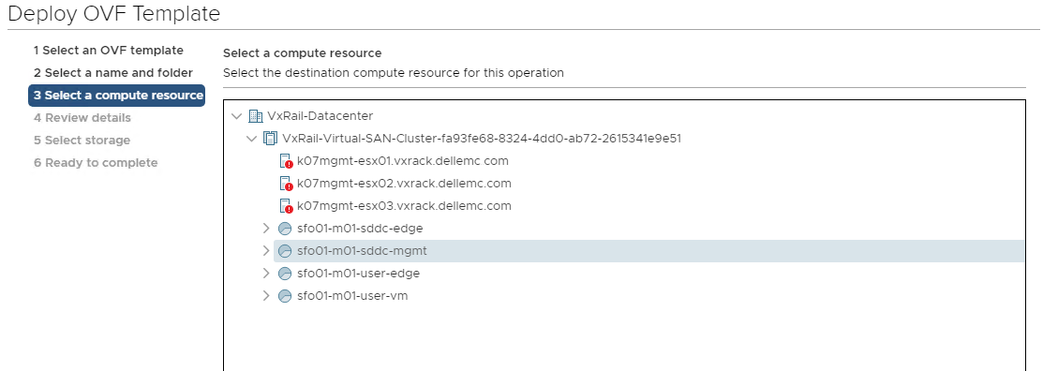

1. Validating (this will take a while):

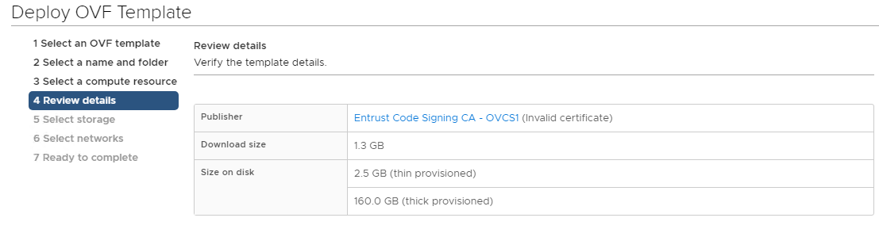

1. Select “VXRAIL-SYSTEM-STORAGE-PROFILE” as the VM Storage Policy:

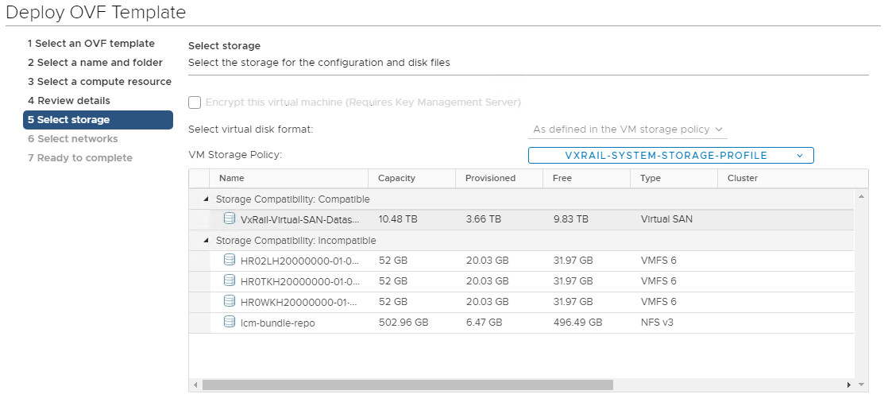

1. Set “vCenter Server Network” as Network 1 and “Management Network” as Network 2:

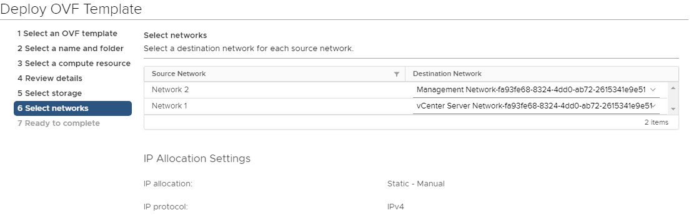

1. Review the details and click “Finish” to complete the deployment, wait the task to be completed:

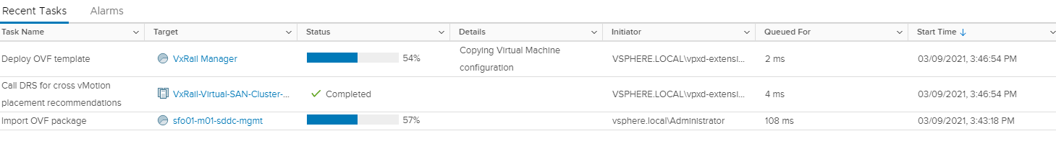

1. Once the virtual machine is deployed, power it on.
2. Open the web console of the virtual machine and configure it
3. Login with factory credential: root/Passw0rd!
4. Set DNS via VAMI



1. Set IP address via VAMI:



1. Verify the DNS resolution via nslookup:

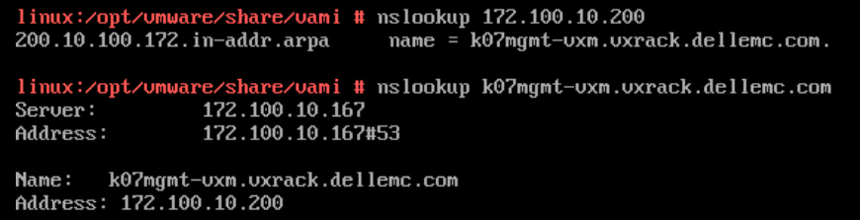

1. Set hostname via VAMI:

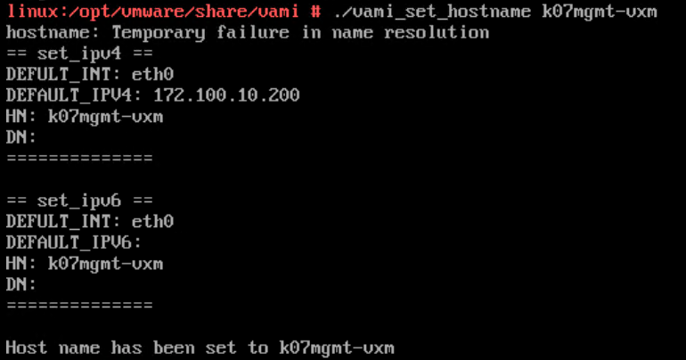

1. Verify the setting from vCenter:

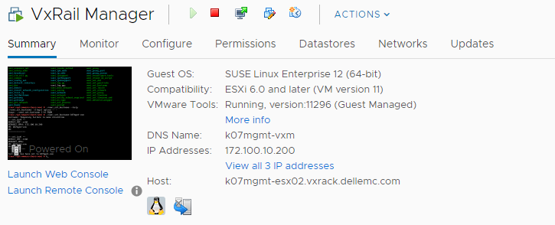

1. Re-set the root password to the customized one
2. Enable root login via “sed -i 's/PermitRootLogin no/PermitRootLogin yes/g' /etc/ssh/sshd_config” and restart sshd service
3. Prerequisite for recovery
4. Close the web console and ssh into the new virtual machine via terminal, you may notice the hostname had been set to the target one:

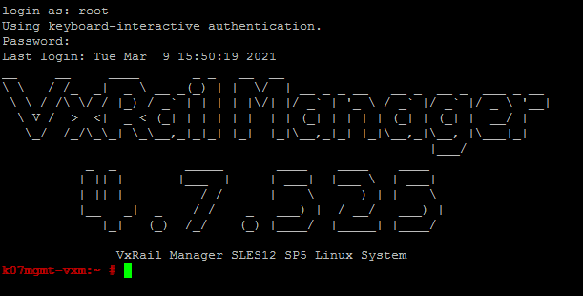

1. Switch to /tmp and create a new folder as “vrmrecovery”
2. Upload the bundle “VRMRecovery.zip” to that folder and unzip it:

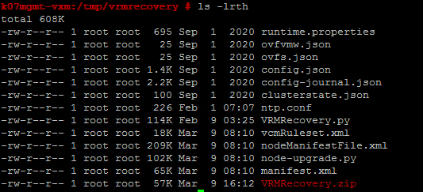

Notes: **vcmRulset.xml, nodeManifestFile.xml, node-upgrade.py and manifest.xml** are version dedicated, you have to prepare them from the corresponding bundle (will not be included in the .zip file by default)

1. Make sure the SSH service of vCenter, PSC and all ESXi hosts in the cluster enabled.
2. Recovery

